

**Mini-Project Report**

**On**

**Typing Speed Test**

**BY**

**Akarsh Singh-62(PRN-1032212466)**

**Under the guidance of Prof: Anita Gunjal**

**MIT-World Peace University (MIT-WPU)**

**Faculty of Engineering**

**School of Computer Engineering & Technology**

**\* 2022-2023\***

**MIT-World Peace University (MIT-WPU)**

**Faculty of Engineering**

**School of Computer Engineering & Technology**

**School of Computer Engineering & Technology**

# CERTIFICATE

**This is to certify that Mr. Akarsh Singh of B. Tech. School of Computer Engineering & Technology, Semester III , PRN. No.1032212466, has successfully completed Mini-Project on**

**Word Counter and Spell Checker**

**To my satisfaction and submitted the same during the academic year 2022 - 2023 towards the partial fulfillment of the degree of Bachelor of Technology in School of Computer Engineering & Technology under Dr. Vishwanath Karad MIT- World Peace University, Pune.**

**{Student Name and Signature} {Guide name and Signature}**

**School of Computer Engineering & Technology**

**INDEX**

|  |  |  |
| --- | --- | --- |
| **CHAPTER** | **CONTENT** | **PAGE NO.** |
| 1. | INTRODUCTION | 01 |
| 2. | PROBLEM STATEMENT | 02 |
| 3. | DATASET | 03 |
| 3.1 | DESCRIPTION | 03 |
| 3.2 | PREPROCESS | 03 |
| 4. | TASK PERFORMED | 06 |
| 4.1 | DATA ANALYSIS | 06 |
| 4.2 | DATA VISUALIZATION | 07 |
| 5. | TOOLS | 11 |
| 5.1 | PYTHON | 11 |
| 5.2 | TKINTER | 11 |
| 5.3 | RANDOM | 12 |
| 5.4 | MATH | 13 |
| 5.5 | VS CODE | 14 |
| 6. | OUTPUT AND VISUALIZATION | 16 |
| 7. | CONCLUSION | 28 |
| 8. | REFERENCES | 29 |

**CHAPTER 1**

**INTRODUCTION**

* Many businesses have met with huge glory as a result of the wide market that revolves around this technology.
* Have you ever thought as to how a small factor as typing speed can turn things around? Speed and time-conscious are the two rules on which all businesses function on.
* This is done by feeding data through the computer. And, for you to accomplish high levels of speed typing, you need to have a fast typing speed.
* It is imperative to have a base line to evaluate your current typing speed. Many free typing tests are conducted online. All you need to is open your search engine and type, "free typing test". Likewise, many search results will pop-up.
* Numerous typing tests come with free online games and tutorials. Follow the given instructions to achieve high levels of typing speed which will make you more successful in your field.
* A typing test is especially important for computer science students as their typing speed determines their productivity and is a good metric for a student to decide how good he/she is.
* All the above points are the reasons why we chose to make a Typing test consisting of a word counter and spelling checker.
* This program’s output will display how many correct as well ass wrong words were typed by the user and also his typing speed in letters per second.

**CHAPTER 2**

**PROBLEM STATEMENT**

* The problem was to develop an application to determine the rate at which typing speed and accuracy were achieved using python programming language.
* Word counter and spell checking are essential if you want to learn how to type faster and accurately, which is an essential skill in the current online world.
* Due to spelling mistakes and slow typing speed people waste a lot of their time and hence their productivity is diminished subsequently.

However, with the help of this typing test a person can determine his typing speed and accuracy.

**CHAPTER 4**

**TASKS PERFORMED**

* Typing speed is measured by the number of words you can type correctly in a set amount of time. A “word” is equivalent to five keystrokes. During a test, both speed and accuracy are measured. You will receive a number that indicates your average words per minute (WPM) and a percentage that indicates your accuracy.
* Taking a typing speed test establishes your average typing speed (WPM) and accuracy, which is an important baseline to know so you can increase speed and improve accuracy with practice. Periodically taking typing speed tests can help you track your progress and measure improvement. You even can use your WPM score from the typing test on your resume to highlight your administrative skills!

**CHAPTER 5**

**TOOLS / LIBRARIES USED**

**SOFTWARE DESCRIPTION**

**A) PYTHON:**

Python is a translated, object-arranged, unusual state programming language with dynamic semantics. Its unusual state worked in information structures, joined with dynamic composing and dynamic authoritative, make it attractive for Rapid Application Development, just as for use as a scripting or paste language to interface existing segments together. Python's basic, simple to learn language structure underlines intelligibility and hence decreases the expense of program support. Python underpins modules and bundles, which empowers program seclusion and code reuse. The Python translator and the broad customary library are accessible in source or parallel structure without charge for every single significant stage.

Frequently, code engineers begin to look all starry eyed at Python on account of the expanded efficiency it provides. Since there is no aggregation step, the alter test troubleshoot cycle is staggeringly quick. Troubleshooting Python programs is simple: a bug or awful information will never cause a division blame. Rather, when the mediator finds a blunder, it raises a special case. At the point when the program does not get the special case, the translator prints a stack follow. A source level debugger permits assessment of nearby and worldwide factors, assessment of discretionary articulations, setting breakpoints, venturing through the code a line at any given moment, etc. The debugger is written in Python itself, vouching for Python's contemplative power. Then again, frequently the speediest methodology to troubleshoot a program is to add a couple of print proclamations to the source: the quick alter test-investigate cycle makes this straightforward methodology successful.

Python is an item situated, abnormal state programming language with incorporated unique semantics essentially for net and application improvement. It is incredibly alluring in the field of Rapid Application Growth since it offers dynamic composing and dynamic limiting alternatives.

Python is generally basic, so it's anything but difficult to learn since it requires a one-of-a-kind language structure that centers on coherence. Designers can peruse and interpret Python code a lot simpler than different dialects. Thus, this decreases the expense of program upkeep and improvement since it enables groups to work cooperatively without huge language and experience obstructions.

Moreover, Python underpins the utilization of modules and bundles, which means that projects can be planned in a secluded style and code can be reused over an assortment of tasks.

**B) TKINTER:**

Tkinter is the most commonly used library for developing GUI (Graphical User Interface) in Python. It is a standard Python interface to the Tk GUI toolkit shipped with Python. As Tk and Tkinter are available on most of the Unix platforms as well as on the Windows system, developing GUI applications with Tkinter becomes the fastest and easiest.

Tkinter is the inbuilt python module that is used to create GUI applications. It is one of the most commonly used modules for creating GUI applications in Python as it is simple and easy to work with. You don’t need to worry about the installation of the Tkinter module separately as it comes with Python already. It gives an object-oriented interface to the Tk GUI tool kit.

**Python Tkinter Geometry**

The Tkinter geometry specifies the method by using which, the widgets are represented on display. The python Tkinter provides the following geometry methods.

* The pack() method
* The grid() method
* The place() metho

**Python Tkinter pack() method**

The pack() widget is used to organize widget in the block. The positions widgets added to the python application using the pack() method can be controlled by using the various options specified in the method call.

However, the controls are less and widgets are generally added in the less organized manner.

**Python Tkinter grid() method**

The grid() geometry manager organizes the widgets in the tabular form. We can specify the rows and columns as the options in the method call. We can also specify the column span (width) or rowspan(height) of a widget.

**Python Tkinter place() method**

The place() geometry manager organizes the widgets to the specific x and y coordinates.

**C) RANDOM:**

Python Random module is an in-built module of Python which is used to generate random numbers. These are pseudo-random numbers means these are not truly random. This module can be used to perform random actions such as generating random numbers, print random a value for a list or string, etc.

Example: Printing a random value from a list

* The random.random() function gives a float number that ranges from 0.0 to 1.0. There are no parameters required for this function.
* random.random():- Returns The second random floating point value within [0.0 and 1) is returned.
* random.uniform(a, b):- Generates a random floating point R in which a <= R <= b if a <= b and b <= R <= a if b < a.
* random.expovariate(lambda):- Returns the random value according to exponential distribution.
* random.gauss(mu, sigma):- Returns the random value according to gaussian distribution.

**D) MATH:**

The Python Math Library provides us access to some common math functions and constants in Python, which we can use throughout our code for more complex mathematical computations. The library is a built-in Python module, therefore you don't have to do any installation to use it. In this article, we will be showing example usage of the Python Math Library's most commonly used functions and constants**.**

Constants in Math Module

The value of numerous constants, including pi and tau, is provided in the math module so that we do not have to remember them. Using these constants eliminates the need to precisely and repeatedly write down the value of each constant. The math module includes the following constants:

* Euler's Number
* Tau
* Infinity
* Pi
* Not a Number (NaN)

**CHAPTER 6**

**OUTPUT AND VISUALIZATION SCREENSHOTS**

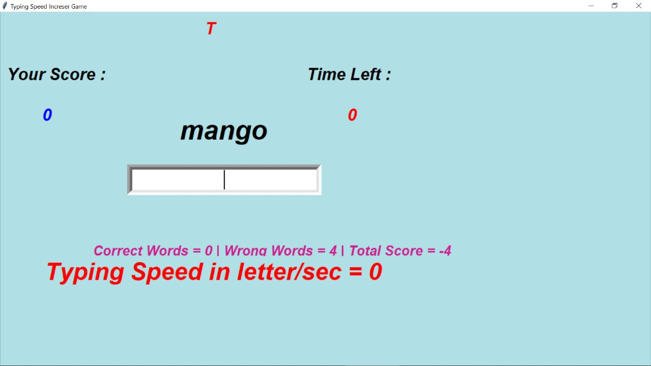

**CHAPTER 7**

**CONCLUSION**

* Thus we have designed an application to count the number of words a user has typed in one minute with spell check using python programming language.
* We did this with the help of multiple python libraries. Our program also does more than just give you the number of words. It also checks your grammar.
* While many people are familiar with spell check, problems associated with grammar are just as, if not more so common than spelling errors.
* It is very important to know how to type accurately, yet quickly to maximize efficiency when working.

**CHAPTER 8**

**REFERENCE**

* <https://www.kaggle.com/code/fahrilianwidiatama/car-details-from-car-daekho/data>
* <https://stackoverflow.co>
* https://github.com